**Neha Malhotra** **R.L. Chemistry Classes M: 9253556635**

**Max Time : 1 hr** **Class = 12th Biology Test**  **Max Marks : 20**

**HUMAN REPRODUCTION**

**[Based on Female Reproductive System]**

1. Multiple choice questions : [ 1 X 4 = 4]
2. Colostrum, the yellowish fluid secreted by mother during the initial days of lactation is very essential to impart immunity to the new born infants because it contains:

|  |  |  |  |
| --- | --- | --- | --- |
| a) immunoglobulin A | b) natural killer cells | c) monocytes | d) macrophages |

1. Match column I and column II

|  |  |  |
| --- | --- | --- |
| Column I | Column II | |
| A. Proliferative phase | I. Testosterone | |
| B. Leydig cell | II. estrogen | |
| C. Spermiogenesis | III. Progesterone | |
| D. Secretory phase | IV. Spermatid | |
| a) A – II ; B – I ; C – IV ; D – III | | | b) A – IV ; B – II ; C – III ; D – I | |
| c) A – IV ; B – III ; C – II ; D – I | | | d) A – IV ; B – III ; C – I ; D – II | |

1. Hormone responsible for the secretion of milk after parturition is :

|  |  |  |  |
| --- | --- | --- | --- |
| a) ICSH | b) prolactin | c) ACTH | d) LH |

1. Onset of menstruation is due to :

|  |  |
| --- | --- |
| a) increase in level of progesterone | b) fall in the level of progesterone |
| c) increase in level of FSH | d) None of the above |

1. Where are fimbriae present in human female reproductive system? Give its function. [ 1 ]
2. Corpus luteum act as temporary endocrine gland. Justify. [ 1 ]
3. Define Menarche and Menopause. [ 2 ]
4. Differentiate between follicular phase and luteal phase of the menstrual cycle. [ 2 ]
5. What is oogenesis? Construct a flow chart exhibiting sequential events of oogenesis. [ 3 ]
6. Draw well labelled diagram of the human female reproductive system. [ 3 ]
7. Study the graph given below and answer the following questions : [ 4 ]

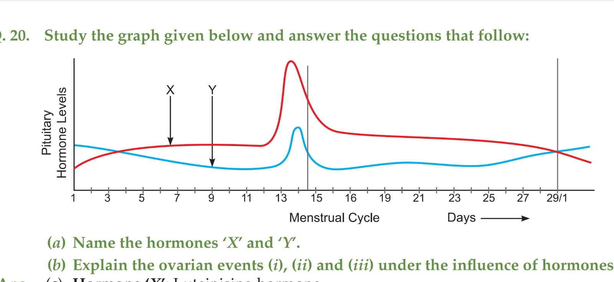

1. Name the hormones ‘X’ and ‘Y’.
2. Identify the ovarian phase during 5th to 13th day of menstrual cycle.
3. What is the importance of ‘X’ hormone?
4. Menstrual cycle are absent during pregnancy. Why?

**Neha Malhotra** **R.L. Chemistry Classes M: 9253556635**

**Max Time : 1 hr** **Class = 12th Biology Test**  **Max Marks : 20**

**HUMAN REPRODUCTION**

**[Based on Female Reproductive System]**

**except menstrual cycle**

1. Multiple choice questions : [ 1 X 5 = 5]
2. Colostrum, the yellowish fluid secreted by mother during the initial days of lactation is very essential to impart immunity to the new born infants because it contains:

|  |  |  |  |
| --- | --- | --- | --- |
| a) immunoglobulin A | b) natural killer cells | c) monocytes | d) macrophages |

1. Ist polar body is formed at which state of oogenesis

|  |  |  |  |
| --- | --- | --- | --- |
| a) Ist meiosis | b) 2nd mitosis | c) Ist mitosis | d) differentiation |

1. Which of the following is a finger like structure that lies at the upper junction of the two labia minora above urethral opening :

|  |  |  |  |
| --- | --- | --- | --- |
| a) Clitoris | b) Oviduct | c) Ampulla | d) Chorionic villi |

1. 10 Oogonia yield 10 primary oocytes, then how many ova are produced on completion of oogenesis?

|  |  |  |  |
| --- | --- | --- | --- |
| a) 5 | b) 10 | c) 20 | d) 40 |

1. In an oocyte, second maturation divisions occurs in :

|  |  |  |  |
| --- | --- | --- | --- |
| a) Ovary | b) abdominal cavity | c) fallopian tube | d) uterus |

1. Where are fimbriae present in human female reproductive system? Give its function. [ 1 ]
2. Corpus luteum act as temporary endocrine gland. Justify. [ 1 ]
3. Write a brief note on ovary. [ 2 ]
4. How will you distinguish between the primary follicle and tertiary follicle, also explain with the help of diagram. [ 2 ]
5. What is oogenesis? Give a brief account of oogenesis. [ 3 ]
6. How many layers are present in human uterus, name them , also define their function. [ 3 ]
7. Study the transverse section of human ovary given below and answer the following questions : [ 3 ]

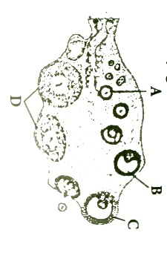

(a) Name the hormone that’s helps in growth of A $→$ B $→$ C.

(b) Name the hormone secreted by A and B

(c) State the role of hormone produced by D.